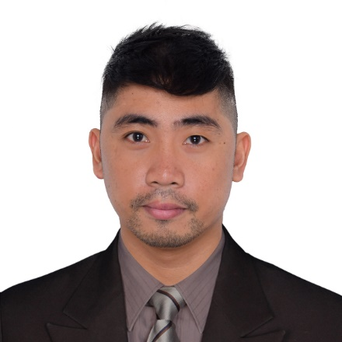

**Angelo Gabriel Sabando Suarez**

***+63966-4358961***

***suarezangelogabriel04@gmail.com***

***Block 330 Lot 25B San Miguel Street  
Brgy. Pembo, City of Makati, Manila, 1218***

**OBJECTIVES:**

* To get an opportunity where I can make the best of my potential and contribute to the organization's growth. Seeking a position in a company where I can launch my career and build a valuable skill set.
* To make use of my interpersonal skills to achieve goals of a company that focuses on customer satisfaction and customer experience.

**SPECIAL SKILLS AND INTERESTS:**

* Able to deal with different people in different levels.
* Hard working and fast learner.
* Patient, kind and understanding.
* Impeccable attention to detail.
* Willing to share ideas, experience and capabilities.
* Determined to comply with company’s requirements.
* Passionate and easy-going person.

**EDUCATIONAL BACKGROUND**

**Food and Beverages NC II**  
Vocational Course - (2011)  
Puerto Princesa School of Arts and Trades (Puerto Princesa City, Palawan)

**Electrical Engineering Tech**Palawan State University (2011)

**WORK EXPERIENCE:**

**Bartender/Server**

Nikkei Nama Bar (July 2023-Present)  
2/F View Deck One Bonifacio High Street  
28th Street Bonifacio Global City, Taguig

**Stockman & Purchaser**

Gerry's Restaurant and Bar (2022-2023)  
Robinsons Palawan Branch  
Puerto Princesa City, Palawan

**Job Description:**

* Requisitions and orders merchandise, supplies, and equipment using guidelines, rules, policies, and laws.
* Audits invoices and checks for accuracy, receipt of material, and compliance with purchase orders.
* Maintains and reviews various purchasing and procurement reports and records and maintains files
* Assists with determining the operational minimum and maximum inventory levels.
* Prepare purchase orders by verifying specifications and prices

**Bartender**Gerry's Restaurant and Bar (2016-2022)

Robinsons Palawan Branch

Puerto Princesa City, Palawan

**Job Description:**

* Mixes and prepares alcoholic and non-alcoholic drinks with accuracy.
* Takes order from and serves drinks to the guest particularly at the counter.
* Checks stock levels of bar supplies and necessary requisitions.
* Checks that all items to be used and served conform to the set standard.
* Obtains and maintains a prescribed bar stock necessary for the operations.

**Dining Team Leader**

Gerry's Restaurant and Bar (2015-2016)

Robinsons Palawan Branch  
 Puerto Princesa City, Palawan

**Job Description:**

* Create an inspiring team environment with an open communication culture
* Set clear team goals
* Delegate tasks and set deadlines
* Oversee day-to-day operation
* Monitor team performance and report on metrics
* Motivate team

**Restaurant Service Crew**Gerry's Restaurant and Bar (January 22,2013 to 2015)

Robinsons Palawan Branch  
Puerto Princesa City, Palawan

**Job Description:**

* Operates the POS for order taking and billing out.
* Studies the menu, familiarizes him/herself with the restaurant’s specialties.
* Takes orders and serve food and beverage items and checks the completeness of all items ordered.
* Checks that all items to be used and served conform to the set standard.
* Does suggestive selling.
* Participates during monthly inventory of Dining Supplies, Equipment &amp; Condiments.
* Performs his tasks based on the customer service standard.

**Food and Beverages Attendant**Ardent Suites Hotel (October 2011 – January 2012)

Puerto Princesa City, Palawan

**CHARACTER REFERENCES**

**Camilo Tampus Jr.**  
Branch Manager  
Contact No. +639776088068

**Wella Omagap**  
Teacher  
Contact No. +639126066580

**Charlemagne Molina**  
Accounting Officer  
Contact No. +639691183785